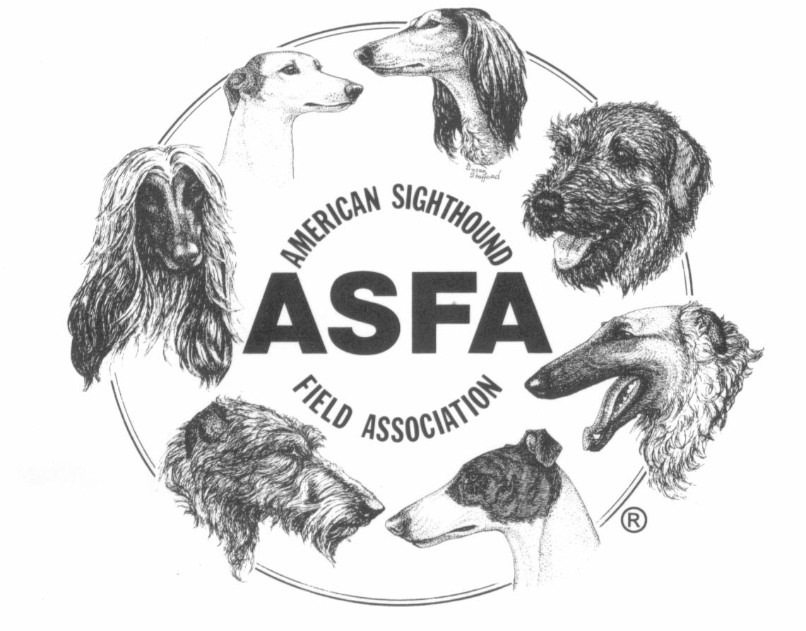
American Sighthound Field Association
2023 Annual Convention of Delegates
18th & 19th March, 2023
Four Points by Sheraton Kansas City Airport
11832 NW Plaza Circle
Kansas City, MO 34153

REGISTRATION FORM

PAY PAL FOR REGISTRATION IS AVAILABLE

Registration must be received by the 26th of February in order to provide you with a convention packet. If you use this form and want to pay using PayPal send the $95 fee to: treasurer@asfa.org.
All mail-in registrations MUST be postmarked by the 19th of February.

Each voting delegate must submit written confirmation from a member club in order to be seated as a voting delegate or alternate for that club. Please submit a separate form for each delegate.

Club _______________________________________________ ( ) Member. ( ) Other

Delegate’s Name __________________________________________________________________

Address _________________________________________________________________________

City ___________________________________ State _________ Zip code _______________

Phone ___________________________ Email _______________________________

( ) Voting Delegate ( ) Alternate. ( ) Observer

Signature of a Club Officer (OTHER THAN DELEGATE OR THEIR SPOUSE) and email address.

Signature Printed Name

Email address: ______________________________________________

Saturday evening dinner will be at the Streetcar Grille & Tavern. Directions will be given at the convention. I plan to attend the Saturday evening dinner: ______ yes ______ no

For questions contact
Kathy Sanders (908-380-3658) TheKathySanders@gmail.com

Mail your registration with check or Paypal to:
Ping Pirrung, 120 Labyrinth Lane, New Bethlehem, PA 16242-1701
asfa.ping@gmail.com

